Sprint 3 -Agility Design Document

November 15, 2022

Table of Contents

1. Executive Summary 3

1.1 Project Overview 3

1.2 Purpose and Scope of this Specification 3

2. Product/Service Description 3

2.1 Product Context 3

2.2 User Characteristics 3

2.3 Assumptions 3

2.4 Constraints 3

2.5 Dependencies 4

3. Requirements 4

3.1 Functional Requirements 4

3.2 Security 4

3.2.1 Protection 4

3.2.2 Authorization and Authentication 4

3.3 Portability 4

4. Requirements Confirmation/Stakeholder sign-off 4

5. System Design 5

5.1 Algorithm 5

5.2 System Flow 6

5.3 Software 7

5.4 Hardware 7

5.5 Test Plan 8

5.6 Task List/Gantt Chart 9

5.7 Staffing Plan 9

# Executive Summary

## Project Overview

The robot will traverse an obstacle course consisting of 3 glass bottles and a ramp made from a large pink binder, before knocking down 10 markers arranged like bowling pins. The robot will complete this task by executing the block code developed within the Sphero application.

## Purpose and Scope of this Specification The purpose of this project is to successfully navigate the obstacle course, and knock down all 10 “pins”.

In scope

The following items are in scope:

* The robot will weave through 3 glass bottles without touching them.
* The robot will make it over the ramp
* The robot will knock over all 10 markers

Out of Scope

The following items are out of scope:

* The robot will stray from the path
* The robot will not run into any obstacles

# Product/Service Description

* This Project is an assignment for *Intro to Problem Solving* (CS 104-01)
* Sprint #3 – Agility is due 11:59, November 29, 2022

## Product Context

* Sprint 3 (Agility) is independent
  + One part of a triathlon
* Connected to a larger project consisting of three parts but Sprint 3 is independent
* Sprint 1 is Endurance, Sprint 3 is Accuracy, Sprint 3 is Agility
* Three group members working collaboratively on all three parts of the project

## User Characteristics

1. Students taking the CS 104-01 course
   * Maximum of 2 or fewer years of computing experience
   * First time using / testing Sphero robot / block code
2. Professor of CS 104-01 course
   * Decades of computing experience
   * Is familiar with the Sphero robot application and the block code

## Assumptions

The robot is assumed to work and perform functions when it is programmed to do so. The block code is assumed to program the Sphero robot to perform as needed. All team members are assumed to be available at the same time to work cooperatively and collaboratively on all parts of the project. All team members are assumed to complete the individual work assigned to them per the Gantt chart. Howard Hall room 208 is assumed to be available when needed.

## Constraints

* Functionality / operation of the Sphero robot
* The blue tape on the ground
* Access to Howard Hall room 208
* Availability of all group members
* Sphero robot application

## Dependencies

* The process must take place in Howard Hall Room 208
* All team members must be available to work cooperatively and collaboratively
* The Sphero Application must be used to control the robot

# Requirements

## Functional Requirements

| Req# | Requirement | Comments | Priority | Date Reviewed | SME Reviewed / Approved |
| --- | --- | --- | --- | --- | --- |
| **AGLTY_01** | The robot will traverse the zip-zag taped lines while avoiding the glass bottles | Sequentially, this is the first part of the project. That means this is the most important | 1 | 11/22 | Approved by Sean Fritz |
| **AGLTY_02** | The robot will go over the binder ramp | Sequentially, this is the second part of the project. As such, this should be done second. | 2 | 11/22 | Approved by Sean Fritz |
| **AGLTY_03** | The robot will knock down all pins | Sequentially, this is done the third part of the project. As such, this should be done last. | 3 | 11/22 | Approved by Sean Fritz |

## Security

A password is necessary to gain access to the computer which contains the block code for the Sphero Robot.

### Protection

* GitHub account, username, and password to access the GitHub repository
* Account username and password for the Sphero.edu account
* Sphero robot kept in safety container when not in use
* Sphero robot frequently charged to perform block code
* Email account with Sphero that has been authenticated

### Authorization and Authentication

A Sphero account with an authenticated email address is necessary

## Portability

* Sphero block code is absolutely host dependent
* Access to the Sphero block code and control of the Sphero robot can be accessed by computer or any mobile device

# Requirements Confirmation/Stakeholder sign-off

Include documentation of the approval or confirmation of the requirements here. For example:

|  |  |  |
| --- | --- | --- |
| Meeting Date | Attendees (name and role) | Comments |
| 11/22 | Sean Fritz | Programming, Recording, Receiving Sensor Data |
| 11/29 | Sean Fritz, Manar Elkader, Anthony Tucci | Reaffirming what portions still need to be completed. |

# System Design

## Algorithm

Develop and describe here the algorithm that will be used to provide the required performance of your software:

//Step One – Zig-Zags

1. Enable Stabilization
2. Roll 315 degrees at 53 speed for 2 seconds
3. Delay for 1 second
4. Roll 45 degrees at 53 speed for 2 seconds
5. Delay for 1 second
6. Roll for 315 Degrees at 53 speed for 2.2 seconds
7. Delay for 2 seconds

//Step Two - Ramp

1. Roll 45 degrees at 128 speed for 2.5 seconds
2. Delay for 2 seconds

//Step Three - Pins

1. Roll 180 degrees at 127 speed for 3.2 seconds
2. Delay for 2 seconds
3. Reset Aim
4. Terminate Program

System Flow

Develop a flowchart (and show here) that accurately depicts how your software application will act to fulfill the algorithm

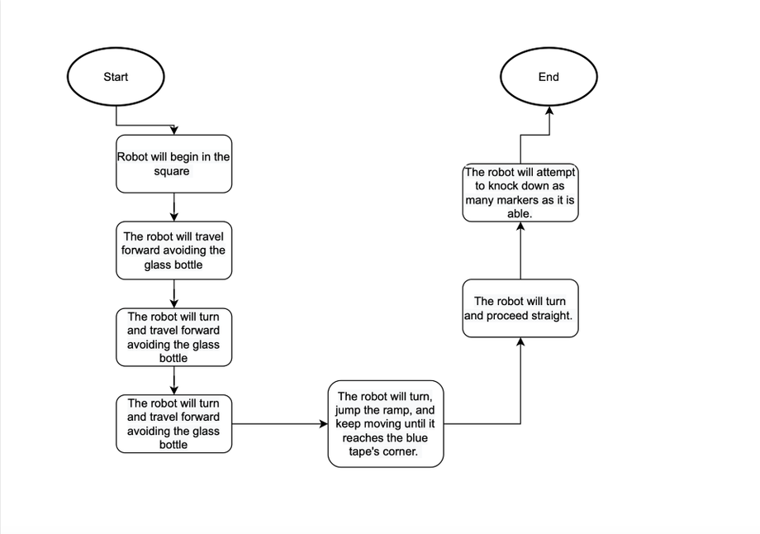

## Software

Describe software languages/platforms/APIs used to develop and deploy this application:

* The Sphero application is required to develop the block code necessary to allow the robot to perform functions. This application is available for download on most common operating systems (in terms of computers) and app stores (in terms of mobile devices). However, it *must* be done on an apple-developed operating system (Mac OS or iOS) in order to obtain the sensor data.
* Executable programs are developed using in-app block code (as pictured below) . This consists of function-templates with modifiable values.

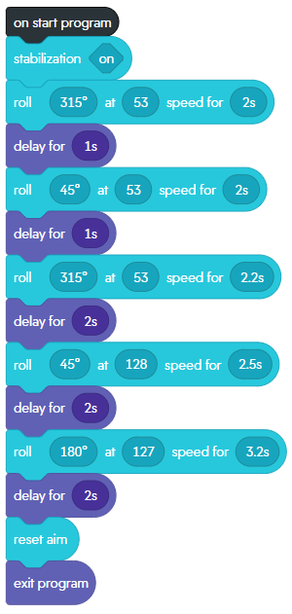

## Hardware

Several hardware platforms were used to develop, test, and demonstrate this application. These include:

* LG Laptop (Windows OS) – For development
* MacBook Pro (Mac OS) – For development
* iPhone (iOS) – For development and retrieval of sensor data
* Sphero Robot – For demonstrating program
* Bluetooth – Sphero robot executed code wirelessly

## Test Plan

| **Reason for Test Case** | **Test Date** | **Expected Output** | **Observed Output** | **Staff Name** | **Pass/Fail** |
| --- | --- | --- | --- | --- | --- |
| 1. Zig-Zag Test no.1 | Nov 22, 2022 | The robot will maneuver around the 3 glass bottles without hitting them. | The robot maneuvered the first line before hissing the glass bottle | Sean Fritz | Fail |
| 1. Zig-Zag Test no.2 | Nov 22, 2022 | The robot will maneuver around the 3 glass bottles without hitting them. | The robot maneuvered the first three lines accurately, but fell short due to the third line being longer than the first two. | Sean Fritz | Fail |
| 1. Zig-Zag Test no.3 | Nov 22, 2022 | The robot will maneuver around the 3 glass bottles without hitting them. | The robot maneuvered around the glass bottles, and followed the tape lines perfectly | Sean Fritz | Pass |
| 1. Ramp Test no.1 | Nov 22, 2022 | The robot will build up enough speed to successfully go over the ramp without straying from the tape course. | The robot does not build up enough speed to properly clear the ramp. | Sean Fritz | Fail |
| 1. Ramp Test no.2 | Nov 22, 2022 | The robot will build up enough speed to successfully go over the ramp without straying from the tape course. | The robot builds too much speed, and passes its target. | Sean Fritz | Fail |
| 1. Ramp Test no.3 | Nov 22, 2022 | The robot will build up enough speed to successfully go over the ramp without straying from the tape course. | The robot ejects off the side of the ramp, rather than going over the top. | Sean Fritz | Fail |
| 1. Ramp Test no.4 | Nov 22, 2022 | The robot will build up enough speed to successfully go over the ramp without straying from the tape course. | The robot successfully goes over the ramp, and reaches its target. | Sean Fritz | Pass |
| 1. Pin Test no.1 | Nov 22, 2022 | The robot will successfully knock over all 10 markers arranged at the end of the track. | The robot misses the pins entirely, as a result of it building up too much speed and driving off-course. | Sean Fritz | Fail |
| 1. Pin Test no.2 | Nov 22, 2022 | The robot will successfully knock over all 10 markers arranged at the end of the track. | The robot hits the puns at a bad angle, only knocking three over | Sean Fritz | Fail |
| 1. Pin Test no.3 | Nov 22, 2022 | The robot will successfully knock over all 10 markers arranged at the end of the track. | The robot successfully knocks over all ten pins. | Sean Fritz | Pass |
|  |  |  |  |  |  |

## Task List/Gantt Chart

Embed your Gantt chart here:

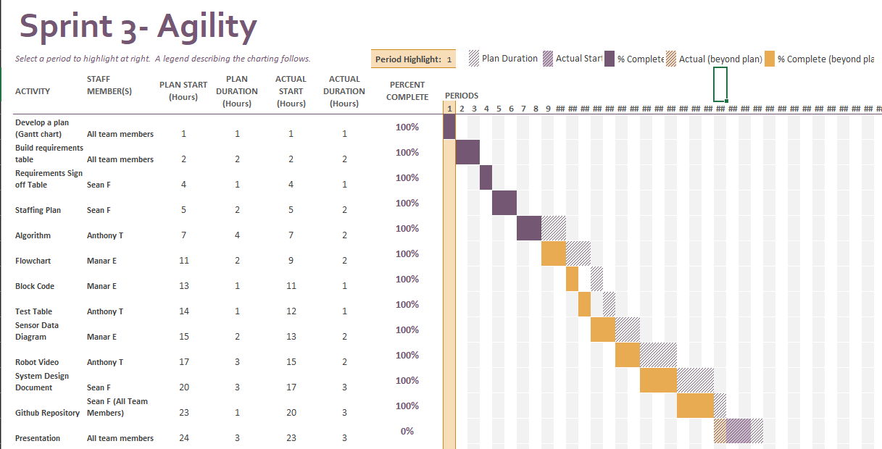

## Staffing Plan

Insert a chart/table that depicts the roles and responsibilities of each team member that worked on this project

| Name | Role | Responsibility | Reports To |
| --- | --- | --- | --- |
| Sean | Planner, Coordinator | Coder, Algorithm, flowchart | Anthony, Manar |
| Anthony | Organizer, tester | Test table, sensor data, staffing plan | Sean, Manar |
| Manar | Documenter, tester | Videographer, system design document | Sean, Anthony |